Chemical Landscape and Drug-Likeness of Tropical Plant Metabolites
  - Haofu Cui, 2025-12-05

Introduction
Plant metabolites are a rich source of bioactive compounds with potential applications in drug discovery. Walker et al. (2023) recently mapped global leaf metabolic variation across 796 plant species, revealing hidden dimensions of plant chemical strategy. To explore the biochemical properties of these metabolites and their potential relevance for drug discovery, I analyzed their publicly available tropical metabolomics dataset (mtbs_tropical_annotations.tsv) using a simplified cheminformatics workflow in Python. My research question is: Do major classes of tropical plant metabolites occupy distinct regions of chemical space, and how do they compare in terms of drug-like properties? We address this by computing molecular descriptors and visualizing patterns across taxonomic classes.

Methods
The dataset was filtered to drop missing or invalid SMILES and remove duplicates to retain unique structures with valid SMILES strings. For each compound, I calculated two standard physicochemical descriptors (molecular weight, logP), one structural complexity metric (FractionCSP3), and a quantitative drug-likeness score (QED), using RDKit. The five most abundant NPClassifier pathways (“Alkaloids”, “Terpenoids”, etc.) were grouped as major categories, while the rest were grouped as “Other”. Three visualizations were generated: (A) chemical space (MolWt vs LogP), (B) QED drug-likeness distribution, and (C) Fsp3 structural complexity. Code and metadata are fully documented in an accompanying Python script.

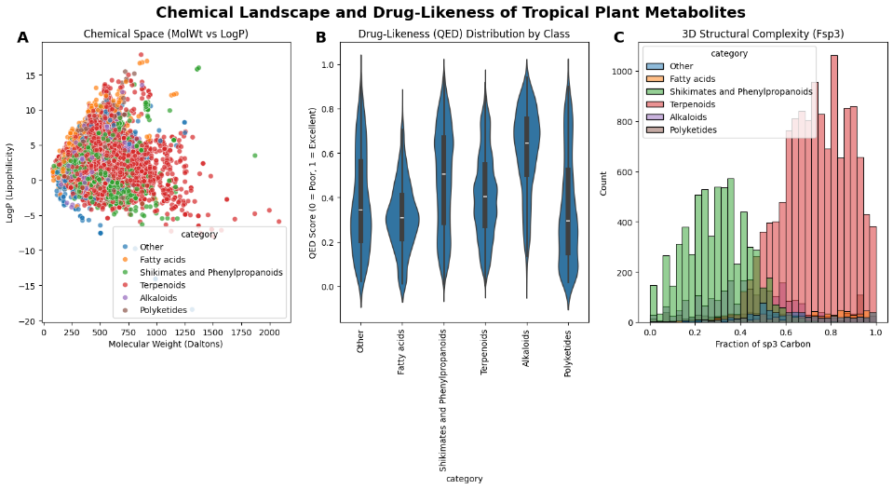
Results
(A) Chemical space: Metabolites span a broad range of molecular weights and logP values, with many exceeding traditional drug-like thresholds (MolWt > 500 or logP > 5). (B) Drug-likeness (QED): Several classes show moderate-to-high QED scores, suggesting inherent drug-like potential. (C) Structural Complexity: Fsp3 distributions vary strongly among metabolic classes.

Discussion
The chemical landscape observed here aligns with Walker et al. (2023): tropical plant metabolites are structurally diverse, chemically rich, and often far outside typical drug-like space. While many compounds exceed Lipinski limits, several classes show moderate-to-high QED scores, suggesting inherent drug-like potential-consistent with historical role of plant metabolites in medicine. The relatively high Fsp3 values of Terpenoids indicate substantial 3D complexity, which is favorable for selectivity and success in clinical development (Lovering, 2013). These findings further demonstrate that tropical plant chemistry harbors underexplored scaffolds with promising pharmaceutical properties. Future work could prioritize high-QED, high-Fsp3 metabolites for bioactivity screening.

References
Walker, T. W. N. et al. (2023). Sci. Adv. 9, eadi4029. https://doi.org/10.1126/sciadv.adi4029
Bickerton, G. R. et al. (2012). Nat. Chem. 4, 341–348. (QED)
Lovering, F. (2013). J. Med. Chem. 56, 3105–3110.
Lipinski, C. A. et al. (1997). Advanced Drug Delivery Reviews, 23(1–3), 3–25.

